The Research on Influencing Factors and Countermeasures of Teacher Career Development in Private Undergraduate Institutions
Na Li Chao Liu Yi Zhai Tong Bu
QingDao Binhai University Qingdao, Shandong Province, 266555, China.

【Author Introduction】
Na Li (1979—), Female,Han Chinese,Ph.D.,Dandong, Liaoning Province,Professor. Research interests: Nursing Education.
Contact Information:
Phone: 13355327271; Email: 893981586@qq.com; Address: Dazhushan Campus, Qingdao Binhai University, No. 1568 Shanchuan Road, West Coast New District, Qingdao, Shandong Province, 266555, China.

Abstract: Based on the Theory of Reasoned Action, this paper explores the influencing factors and countermeasures of teacher career development in private undergraduate institutions through questionnaire surveys. The study finds that teachers generally experience heavy workloads and time pressures, but most believe that the academic atmosphere and research activities at the school have a positive impact on their career development. The evaluation mechanisms and promotion channels are considered fair and effective, but there is still room for improvement. Teachers hold a positive attitude towards career development opportunities and promotion channels, but they perceive limited development space and promotion opportunities. Teachers' personal comprehensive qualities and abilities, as well as the development opportunities and support provided by the school, are considered key factors for career development. Disciplinary professional background, academic accumulation, research capabilities, and teacher collaboration and exchange have significant impacts on career development. Based on the findings, the following strategies are proposed: 1) optimizing the work environment and reducing work pressure; 2) fostering a positive academic atmosphere; 3) improving evaluation mechanisms and promotion channels; 4) providing continuous professional training and development support; and 5) strengthening the construction of disciplinary professional background and research capabilities.
Keywords:Private Applied Undergraduate Institutions; Teacher Career Development; Countermeasures; Theory of Reasoned Action
1. Background
With the continuous advancement of educational system reforms and economic development, private applied undergraduate institutions are playing an increasingly important role in talent cultivation. However, as the backbone of the educational enterprise, teachers' career development is influenced by numerous factors. This study aims to explore the influencing factors and countermeasures of teacher career development in private applied undergraduate institutions, providing theoretical support and practical guidance for enhancing teachers' professional development levels.
1.1 Theoretical Foundation
The Theory of Reasoned Action (TRA), proposed by Fishbein and Ajzen, is a social psychology theory used to explain individual behavior. The theory posits that an individual's behavioral intention is influenced by two primary factors: attitude and subjective norm ^{[1]}. In the context of teacher career development in private applied undergraduate institutions, the Theory of Reasoned Action can be employed to analyze teachers' attitudes towards career development and their subjective norms regarding what constitutes the correct behavior. By measuring teachers' attitudes and subjective norms, it is possible to predict their behavioral intentions, thereby uncovering the influencing factors and countermeasures for teacher career development. The Theory of Reasoned Action will provide a robust theoretical foundation for the study, enhancing the understanding of the underlying motivations behind teachers' career development decisions.
1.2 Model Construction
The TRA model primarily consists of four key components: (1) Attitude: The individual's cognitive evaluation of a specific behavior, i.e., their perceptions of the behavior's goodness, importance, etc., which can be comprehensively measured through the individual's cognition, beliefs, and emotions regarding the behavior. (2) Subjective Norm: The extent to which the individual believes that significant others expect them to engage in or refrain from a particular behavior, including the expectations and attitudes of family, friends, colleagues, etc. (3) Behavioral Intention: The individual's plans and intentions regarding a specific behavior, i.e., whether they intend to perform the behavior. (4) Behavior: The actual behavior performed by the individual, including the influence of attitude and subjective norm on behavioral intention and the ultimate behavior [2]. These components interact with each other, forming the Theory of Reasoned Action model, which is used to explain and predict specific individual behaviors.
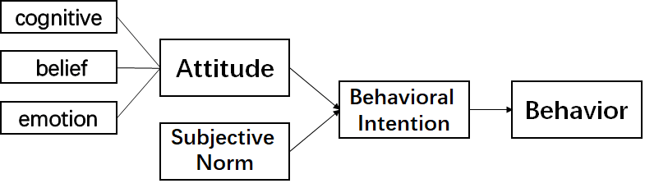
Figure 1: Theory of Reasoned Action Model Diagram

This study, based on the “Theory of Reasoned Action model”, delves into the career development of teachers in private applied undergraduate institutions. Within this model framework, teachers' attitudes toward career development encompass their overall evaluation of the education industry and their perceptions of personal abilities and career prospects. Subjective norms reflect the expectations and influences of key groups such as family, colleagues, and students on teachers' professional behaviors. Through a meticulously designed questionnaire survey, this research aims to collect data on teachers' attitudes and subjective norms regarding career development factors, to explore their behavioral intentions, and thereby uncover the intrinsic motivations and extrinsic pressures behind teachers' career development. The questionnaire covers teachers' personal attitudes, subjective norms, career development intentions, and actual behaviors, striving for a comprehensive analysis of the key factors influencing teachers' career development. The study provides theoretical support for formulating targeted strategies to promote the professional growth and career planning of teachers in private applied undergraduate institutions.
1.3 Research Hypotheses
1.3.1 Teachers' Personal Attitudes Have a Significant Positive Impact on Their Career Development Intentions
This study hypothesizes that teachers' personal attitudes, i.e., their intrinsic beliefs and evaluations about career development, have a significant positive impact on their career development intentions. Specifically, when teachers hold a positive attitude towards career development, such as believing that it can lead to personal growth, satisfaction, and career advancement opportunities, they are more inclined to take actions to promote their own career development. Conversely, if teachers hold a negative attitude towards career development, perceiving it as challenging, uncertain, or inconsistent with their personal values, they may lack the motivation to drive their own career development [3]. Therefore, teachers' personal attitudes are considered a key psychological factor influencing their career development intentions. This attitude not only reflects teachers' cognitive evaluations of career development but also predicts their future career development behaviors.
1.3 Research Hypotheses
1.3.1 Teachers' Personal Attitudes Have a Significant Positive Impact on Their Career Development Intentions
This study hypothesizes that teachers' personal attitudes, i.e., their intrinsic beliefs and evaluations about career development, have a significant positive impact on their career development intentions. Specifically, when teachers hold a positive attitude towards career development, such as believing that it can lead to personal growth, satisfaction, and career advancement opportunities, they are more inclined to take actions to promote their own career development. Conversely, if teachers hold a negative attitude towards career development, perceiving it as challenging, uncertain, or inconsistent with their personal values, they may lack the motivation to drive their own career development [3]. Therefore, teachers' personal attitudes are considered a key psychological factor influencing their career development intentions. This attitude not only reflects teachers' cognitive evaluations of career development but also predicts their future career development behaviors.
1.3.2 Teachers' Subjective Norms Have a Significant Positive Impact on Their Career Development Intentions
This study hypothesizes that teachers' subjective norms, i.e., their perceptions of societal and organizational expectations regarding career development, have a significant positive impact on their career development intentions [4]. When teachers perceive expectations from peers, school management, and societal cultural backgrounds, believing that pursuing career development is a normative and encouraged behavior, their career development intentions are likely to be strengthened. These subjective norms may stem from collective recognition of career success, organizational support for professional growth, or general awareness of promotion paths within the education industry [5]. Therefore, teachers' subjective norms not only shape their social expectations of career development but also motivate their intrinsic drive to pursue career development, thereby encouraging them to engage more actively in career development activities.
1.3.3 Teachers' Career Development Intentions Have a Significant Positive Impact on Their Career Development Behaviors
This study hypothesizes that teachers' career development intentions have a significant positive impact on their career development behaviors. Strong career development intentions drive teachers to actively seek opportunities to learn new knowledge and skills, participate in professional training, and pursue innovation in teaching and research [6]. This intention is the intrinsic motivation for teachers to go beyond daily teaching and commit to continuous professional growth and self-improvement. Therefore, career development intentions are not only a core element of teachers' personal career planning but also a key factor that motivates them to take concrete actions to achieve their career goals.
1.3.4 Teachers' Career Development Behaviors Have a Significant Positive Impact on Their Career Development Outcomes
This study hypothesizes that teachers' career development behaviors have a significant positive impact on their career development outcomes. Actively participating in professional development activities, such as academic seminars, innovative teaching methods, research projects, and interdisciplinary collaborations, not only enhances teachers' teaching and research capabilities but also strengthens their influence and competitiveness in the academic and educational fields [7]. Career development behaviors are the direct pathways for teachers to achieve their career goals, attain professional achievements, and enhance job satisfaction. By effectively implementing these behaviors, teachers can gradually realize their personal career visions and achieve significant career development outcomes in the education sector.
2 Research Design
This study aims to delve into the key influencing factors of teacher career development in private applied undergraduate institutions and propose corresponding countermeasures. The research design employs a combination of quantitative and qualitative methods. Initially, a questionnaire survey is conducted to collect a large amount of data for quantitative analysis of the correlations between teachers' personal attitudes, subjective norms, career development intentions, and career development behaviors. Simultaneously, typical cases are selected for in-depth interviews to reveal the intrinsic mechanisms and complex relationships of the influencing factors through qualitative research. Specific details of the questionnaire survey are shown in Table 1.
Table 1: Survey Scale for Influencing Factors of Teacher Career Development
Dimension | Item | Reference Theory/Research Scale
Personal Attitude | Do you feel that your workload is too heavy or that you are under too much time pressure? | Work Overload and Work Stress Research/Work Stress Questionnaire - WSQ
Personal Attitude | Do you feel a lack of balance between work and life? | Work-Life Balance Theory/Work-Life Balance Questionnaire (WLBQ)
Personal Attitude | To what extent do the school's academic atmosphere and teaching-research activities influence teachers' career development? | Teacher Career Development Theory and Research on the Impact of Academic Environment on Teachers/Teacher Career Development Scale
Subjective Norm | Do you believe that the evaluation mechanisms and promotion channels provided by the school are fair and effective? | Research on the Fairness of Evaluation Mechanisms and Promotion Channels/Evaluation System Fairness Scale
Subjective Norm | To what extent do you believe that teacher evaluation and promotion mechanisms promote teachers' career development? | Research on the Promotion Mechanisms of Teacher Career Development/Teacher Career Development Scale and Analysis of the Impact of Promotion Mechanisms
Subjective Norm | How satisfied are you with the current evaluation system and promotion mechanisms? | Research on the Satisfaction with Evaluation Systems and Promotion Mechanisms/Evaluation Satisfaction Scale and Promotion Mechanism Satisfaction Assessment
Career Development Intention | Do you feel a lack of development space and promotion opportunities in your work? | Research on Career Development Space and Promotion Opportunities/Career Development Opportunities Scale
Career Development Intention | What do you believe is the most influential factor on teachers' career development? | Research on Influencing Factors of Teacher Career Development/Analysis of Influencing Factors on Career Development
Career Development Intention | Are you satisfied with the career development opportunities and promotion channels provided by the school? | Research on Satisfaction with Career Development Opportunities and Promotion Channels/Career Development Satisfaction Scale
Career Development Behavior | To what extent do you believe that disciplinary background and academic accumulation are important to teachers' career development? | Research on the Importance of Disciplinary Background and Academic Accumulation/Disciplinary Background Importance Scale
Career Development Behavior | What impact do you believe teachers' research capabilities have on their career development? | Research on the Impact of Teachers' Research Capabilities/Research Capability Impact Scale
Career Development Behavior | To what extent do you believe that teacher communication and collaboration influence career development? | Research on the Impact of Teacher Communication and Collaboration/Communication and Collaboration Impact Scale
3.1 Sample Information
The survey subjects primarily consisted of middle-aged teachers from multiple private undergraduate institutions, with a total of 200 questionnaires distributed and 198 collected. Among them, teachers aged 31-40 accounted for the highest proportion, reaching 55.77%, indicating that they are the main force in private applied undergraduate institutions. In terms of gender ratio, female teachers dominated with a proportion of 84.62%, while male teachers accounted for only 15.38%. The marital status was predominantly married with children, accounting for 51.92%, while unmarried teachers accounted for 30.77%. In terms of professional titles, the majority held the title of lecturer, with a proportion of 51.92%, followed by assistant lecturers and associate professors. The educational level was mainly master's degree graduates and those currently pursuing a master's degree, accounting for 65.38%, while doctoral degree graduates and those currently pursuing a doctoral degree accounted for 23.08%. The distribution of working years was relatively even, with the highest proportions being teachers with 6-10 years and >15 years of experience, both at 21.15%. In terms of job positions, the majority were engaged in teaching, accounting for 59.62%, followed by those who combined teaching with administrative duties, accounting for 32.69%. These sample information provides basic data on the structure and characteristics of the teacher workforce, laying the foundation for further research analysis.
3.2 Analysis of Personal Attitude Results
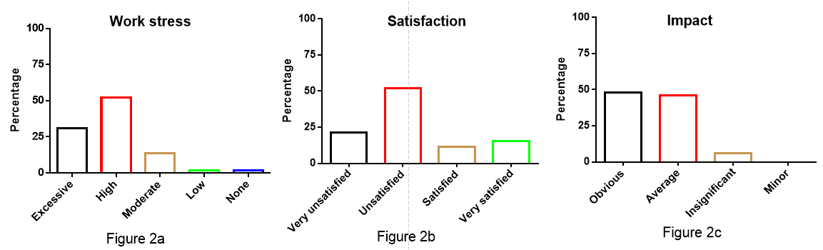
Figure 2a: Whether the Workload is Overwhelming or There is Excessive Time Pressure
Figure 2b: Whether There is a Lack of Balance Between Work and Life
Figure 2c: The Extent to Which the Academic Atmosphere and Teaching-Research Activities of the School Influence Teachers' Career Development
Figures 2a-c show that the majority of teachers (51.92%) occasionally feel that their workload is overwhelming or that there is excessive time pressure, while few teachers (13.46%) often feel that their workload is too heavy or that the pressure is too great. Regarding the balance between work and life, a certain proportion of teachers (27%) occasionally feel a lack of balance, while the proportion of teachers who often feel a lack of balance is relatively low (21.15%). For the academic atmosphere and teaching-research activities of the school, most teachers (48.08%) believe that these factors have well promoted their career development, while the remaining teachers (46.15%) believe that these activities have a certain impact on career development. Only a small number of teachers (5.77%) believe that the impact is not very noticeable. Overall, teachers generally recognize the positive role of the school's academic atmosphere and teaching-research activities in their career development.
3.3 Analysis of Subjective Norm Results
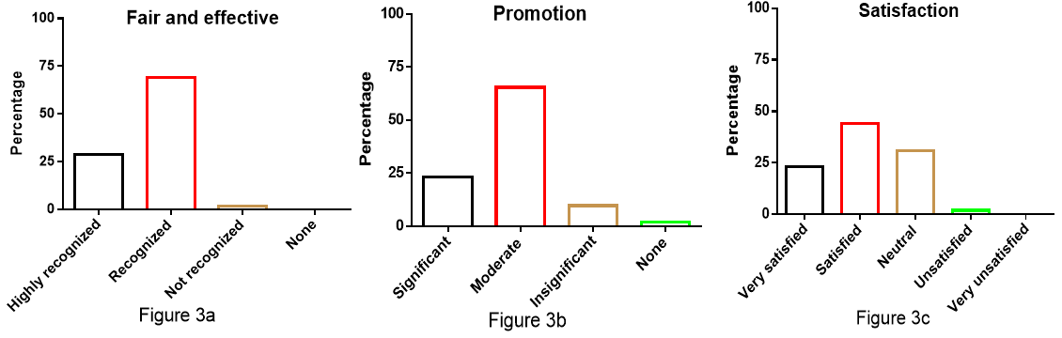
Figure 3a: Recognition of the Fairness and Effectiveness of the Evaluation Mechanisms and Promotion Channels Provided by the School
Figure 3b: The Extent to Which Teacher Evaluation and Promotion Mechanisms Promote Teachers' Career Development
Figure 3c: Satisfaction with the Current Evaluation System and Promotion Mechanism
Figures 3a-c show that the majority of teachers (69.23%) believe that the school's evaluation mechanisms and promotion channels are fair and effective, but still need improvement. Regarding the extent to which evaluation and promotion mechanisms promote career development, most teachers (65.38%) believe that there is some promotion, while 23.08% of teachers believe that these mechanisms effectively promote career development. In terms of satisfaction, 44.23% of teachers expressed satisfaction, 23.08% of teachers were very satisfied, and 30.77% of teachers found the evaluation system and promotion mechanism to be average. Overall, teachers hold a relatively positive attitude towards the current evaluation and promotion mechanisms, but generally believe that there is room for improvement.
3.4 Analysis of Career Development Intention Results
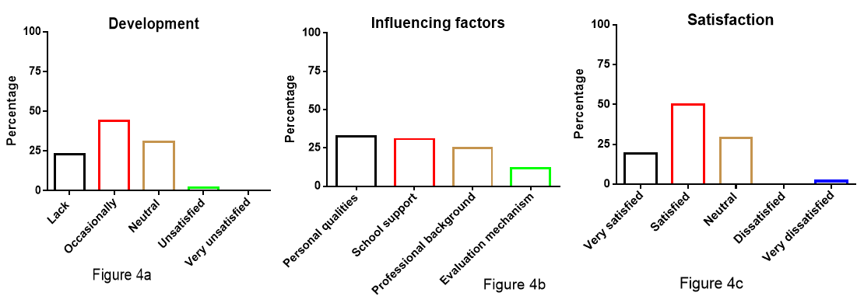
Figure 4a: Whether There is a Lack of Development Space and Promotion Opportunities in the Work
Figure 4b: The Most Influential Factor on Teachers' Career Development
Figure 4c: Satisfaction with the Career Development Opportunities and Promotion Channels Provided by the School
Figures 4a-c show that the majority of teachers (57.69%) occasionally feel a lack of development space and promotion opportunities, while the proportion of teachers who often feel a lack is relatively low (11.54%). Regarding the most influential factor on teachers' career development, teachers' personal comprehensive qualities and abilities (32.69%) and the development opportunities and support provided by the school (30.77%) are considered the most important. For the career development opportunities and promotion channels provided by the school, 50% of teachers expressed satisfaction, 19.23% of teachers were very satisfied, and 28.85% of teachers found them to be average. Overall, teachers hold a relatively positive attitude towards career development opportunities and promotion channels, but there is still room for improvement.
3.5 Analysis of Career Development Behavior Results
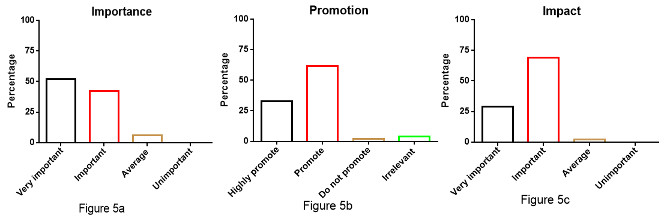
Figure 5a: The Importance of Disciplinary Background and Academic Accumulation to Teachers' Career Development
Figure 5b: The Impact of Teachers' Research Capabilities on Career Development
Figure 5c: The Extent to Which Teacher Communication and Collaboration Influence Career Development
Figures 5a-c show that the vast majority of teachers (51.92%) believe that disciplinary background and academic accumulation are very important to teachers' career development, serving as the foundation for their career development. Regarding teachers' research capabilities, 61.54% of teachers believe that it has some promotion, while 32.69% of teachers believe that it greatly promotes teachers' career development. In terms of teacher communication and collaboration, 69.23% of teachers believe that it has a certain impact on career development, while 28.85% of teachers believe that it is very important for career development. These data indicate that teachers generally recognize the importance of professional background, research capabilities, and communication and collaboration for career development.
4. Results Analysis
This study, based on the Theory of Reasoned Action, explores the influencing factors of teacher career development in private applied undergraduate institutions and their corresponding strategies. The Theory of Reasoned Action emphasizes the interplay between personal attitudes, subjective norms, career development intentions, and career development behaviors. The research results show that factors such as teachers' perceptions of workload, academic atmosphere, evaluation mechanisms, development opportunities, and professional background all significantly influence their career development attitudes and behaviors. Teachers' feelings of heavy workload and time pressure affect their attitudes towards work-life balance, which in turn may influence their career development intentions. The academic atmosphere and teaching-research activities are generally considered to have a positive effect on career development, indicating that schools should continue to foster a favorable academic environment to enhance teachers' subjective norms and career development intentions. The fairness and effectiveness of evaluation mechanisms and promotion channels are directly related to teachers' career development satisfaction, thereby affecting their career development behaviors. Schools should ensure that the evaluation system fairly reflects teachers' work performance and provide transparent promotion paths to enhance teachers' positive attitudes and behaviors towards career development. Teachers' emphasis on personal comprehensive qualities and abilities, as well as their expectations for development opportunities and support provided by the school, reflect their needs for intrinsic motivation and extrinsic incentives for career development. Schools should provide continuous professional training and career development support to meet teachers' personal development needs and promote their career development behaviors.
In conclusion, private applied undergraduate institutions should comprehensively consider teachers' working environment, academic atmosphere, evaluation mechanisms, and development opportunities to formulate corresponding strategies. These strategies should aim to stimulate teachers' career development intentions and encourage them to actively engage in career development behaviors, thereby enhancing educational quality and the overall quality of the teaching staff.
5. Countermeasures
Based on the Theory of Reasoned Action, personal attitudes, subjective norms, career development intentions, and career development behaviors are key factors influencing teacher career development in private applied undergraduate institutions. To promote teachers' career development, schools should adopt the following strategies:
5.1 Optimize Working Environment and Reduce Work Pressure
Schools should reduce teachers' work pressure by reasonably distributing work tasks and time to improve their attitudes towards work-life balance. For example, flexible work hour systems, mental health support and counseling services, and the establishment of teacher mutual aid groups can help teachers cope with work pressure. These measures help enhance teachers' job satisfaction, thereby strengthening their career development intentions and behaviors.
5.2 Foster a Positive Academic Atmosphere
Schools should continue to strengthen the construction of the academic atmosphere, encouraging teachers to participate in teaching-research activities such as regular academic lectures, seminars, and workshops, as well as supporting teachers in participating in academic exchanges and collaborative projects. These activities not only enhance teachers' subjective norms but also strengthen their career development intentions, thereby promoting their active career development behaviors.
5.3 Improve Evaluation Mechanisms and Promotion Channels
To ensure the fairness and effectiveness of evaluation mechanisms and promotion channels, schools should regularly review and update evaluation criteria to ensure they accurately reflect teachers' work performance. Additionally, schools should provide transparent promotion paths, allowing teachers to clearly understand the conditions and processes for promotion. This approach helps enhance teachers' satisfaction with career development, thereby motivating them to more actively engage in career development behaviors.
5.4 Provide Continuous Professional Training and Development Support
Schools should prioritize the enhancement of teachers' personal comprehensive qualities and abilities by offering regular professional training, seminars, and online learning resources to help teachers continuously update their knowledge and skills. Additionally, schools should establish career development counseling services to provide personalized career planning advice for teachers. These support measures can meet teachers' intrinsic motivation and extrinsic incentive needs, thereby promoting their career development behaviors.
5.5 Strengthen Disciplinary Background and Research Capability Construction
Schools should encourage teachers to strengthen their disciplinary background and academic accumulation by providing research project funding, academic publication support, and research achievement rewards to stimulate teachers' research enthusiasm. Additionally, schools should promote communication and collaboration among teachers, establishing interdisciplinary research teams to enhance teachers' research capabilities and academic influence. These measures help teachers recognize the importance of professional background and research capabilities for career development, thereby strengthening their career development intentions and behaviors.
6. Results and Outlook
This study, through questionnaire surveys and field interviews, delved into the influencing factors of teacher career development in private applied undergraduate institutions and proposed corresponding countermeasures based on the Theory of Reasoned Action. The research found that factors such as working environment, academic atmosphere, evaluation mechanisms, development opportunities, and professional background significantly influenced teachers' career development attitudes and behaviors. To enhance teachers' career development, schools should optimize the working environment, foster a positive academic atmosphere, improve evaluation mechanisms and promotion channels, provide continuous professional training and development support, and strengthen disciplinary background and research capability construction.
In the future, private applied undergraduate institutions should continue to focus on the importance of teacher career development and make it one of the core strategies for school development. Schools should further explore and implement more effective teacher career development strategies to attract and retain outstanding teaching talent, enhance teachers' teaching quality and research capabilities. Additionally, schools should strengthen cooperation with industry to provide teachers with more practical opportunities and platforms, promoting their professional growth and academic development. Through these efforts, private applied undergraduate institutions will be able to build a high-quality, high-level teaching staff, providing solid support for school development and student cultivation.
References:
[1] Armitage CJ, Conner M. Efficacy of the Theory of Planned Behaviour: a meta-analytic review. Br J Soc Psychol. 2001 Dec;40(Pt 4):471-99.
[2] Godin G, Kok G. The theory of planned behavior: a review of its applications to health-related behaviors. Am J Health Promot. 1996 Nov-Dec;11(2):87-98.
[3]Garbrah W, Kankkunen P, Välimäki T. Development and validation of gerontological nurse teacher scale. Nurse Educ Pract. 2020 Mar;44:102763.
[4]Lihua D. An Extended Model of the Theory of Planned Behavior: An Empirical Study of Entrepreneurial Intention and Entrepreneurial Behavior in College Students. Front Psychol. 2022 Jan 25;12:627818.
[5]Ivanishchenko K, Busana G, Reuter RAP. Understanding factors affecting fundamental school teachers' use of technology in Luxembourg through a survey study. Heliyon. 2024 Mar 27;10(7):e28704.
[6]Yang J. Understanding and Enhancing Chinese TEFL Teachers' Motivation for Continuing Professional Development Through the Lens of Self-Determination Theory. Front Psychol. 2021 Nov 25;12:768320.
[7]Weinberg AE, Balgopal MM, Sample McMeeking LB. Professional Growth and Identity Development of STEM Teacher Educators in a Community of Practice. Int J Sci Math Educ. 2021;19(Suppl 1):99-120.

【Funding Projects】
1. Key Project of the China Higher Education Society, "Research on the Career Development Paths and Influencing Factors of Teachers in Private Applied Undergraduate Institutions" (23PXZ0203)
2. Shandong Province Undergraduate Teaching Reform Research Project, "Innovative Research and Practice of Diversified Nursing Talent Training System for Specialized Upgrade Based on "Medical-Educational Collaboration and School-Hospital Cooperation" (M2022049)
3. Qingdao Binhai University Key Teaching Reform Research Project, "Innovative Strategies for Applied Nursing Specialty Experimental Teaching Driven by the Concept of "Post-Course-Competition-Certificate" (2024JZ10)"

